**Errors List**

Every form is labeled in bottom left corner – please use as reference

**Teacher Button:** NAVIGATION IS CORRECT but ERROR ON PAGE

* There is an ERROR now that when we add a teacher it gets added to the student list – we should see Teacher list on this page and see teachers as they are added

**Subject Button:** NAVIGATION IS CORRECT

**Instructor Button:** NAVIGATION ERROR! Should Navigate to Manage Teacher/Subject Form – allows to indicate which subjects a teacher is instructor of

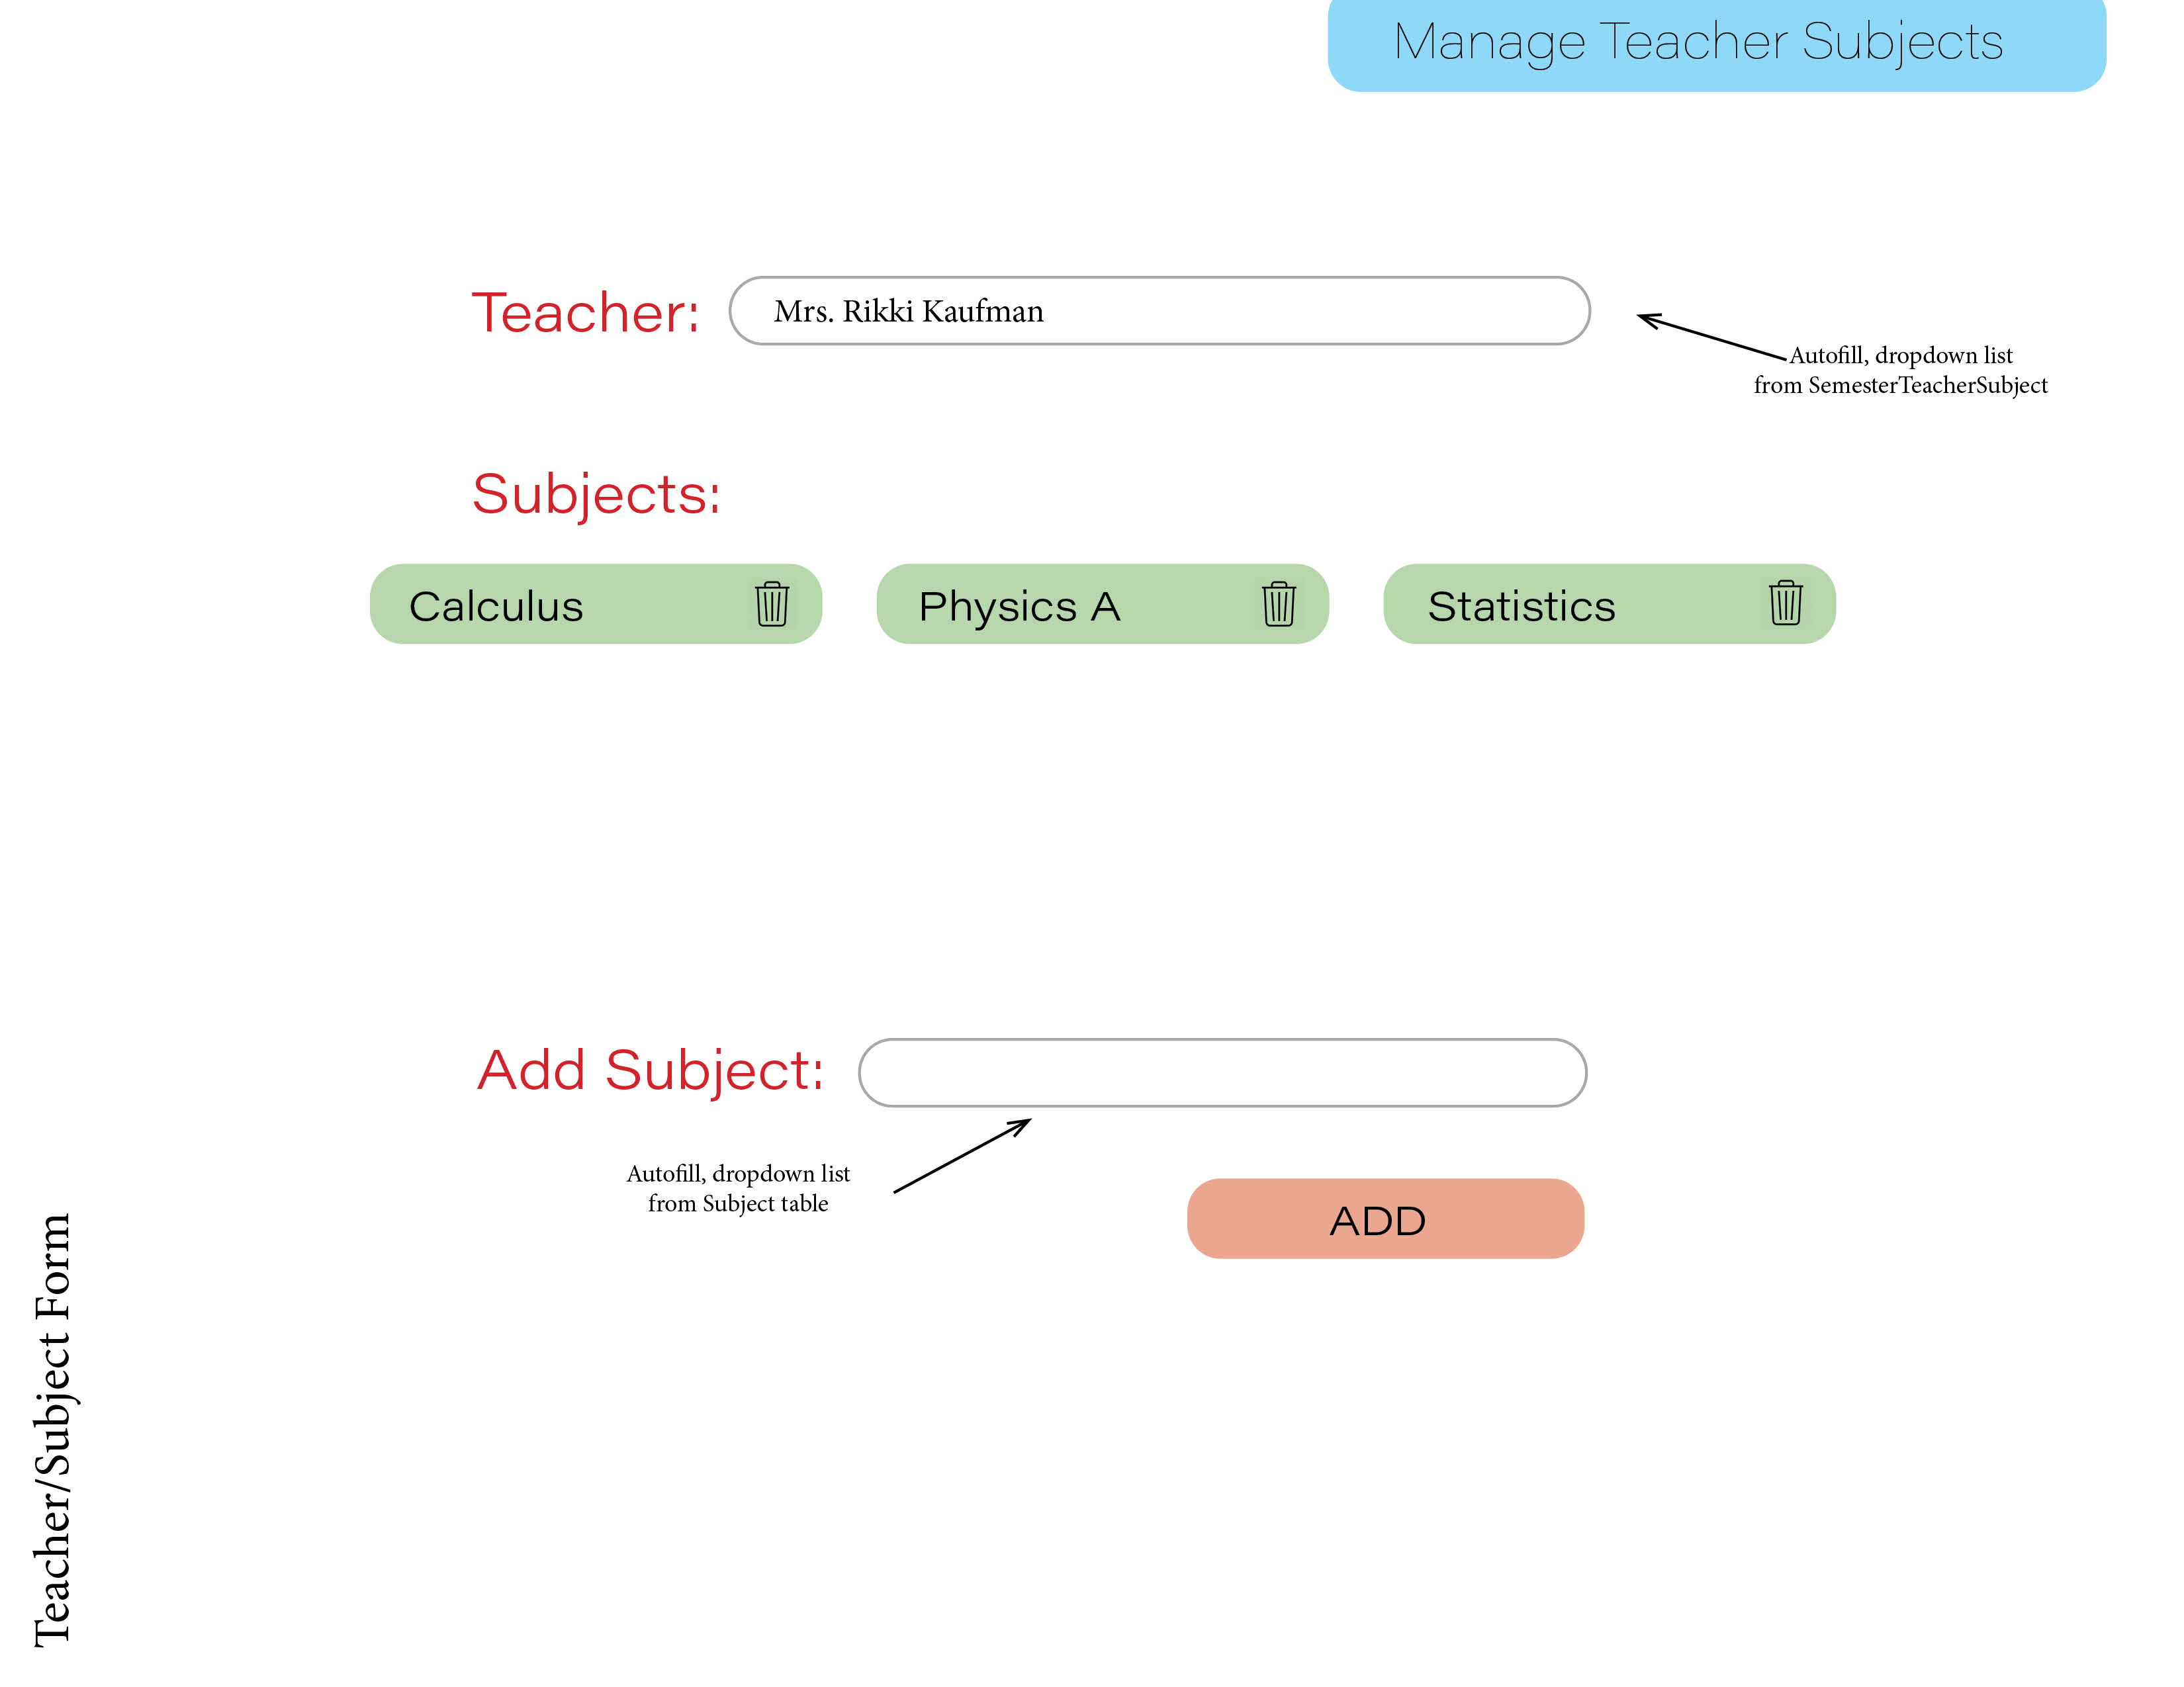

**Student Button:** NAVIGATION IS CORRECT Navigate to Student List

* ERROR we see both students and teachers on this list – it should only show students under the entry form

**NEW STUDENT Button:** NAVIGATION ERORR – should navigate to new student form

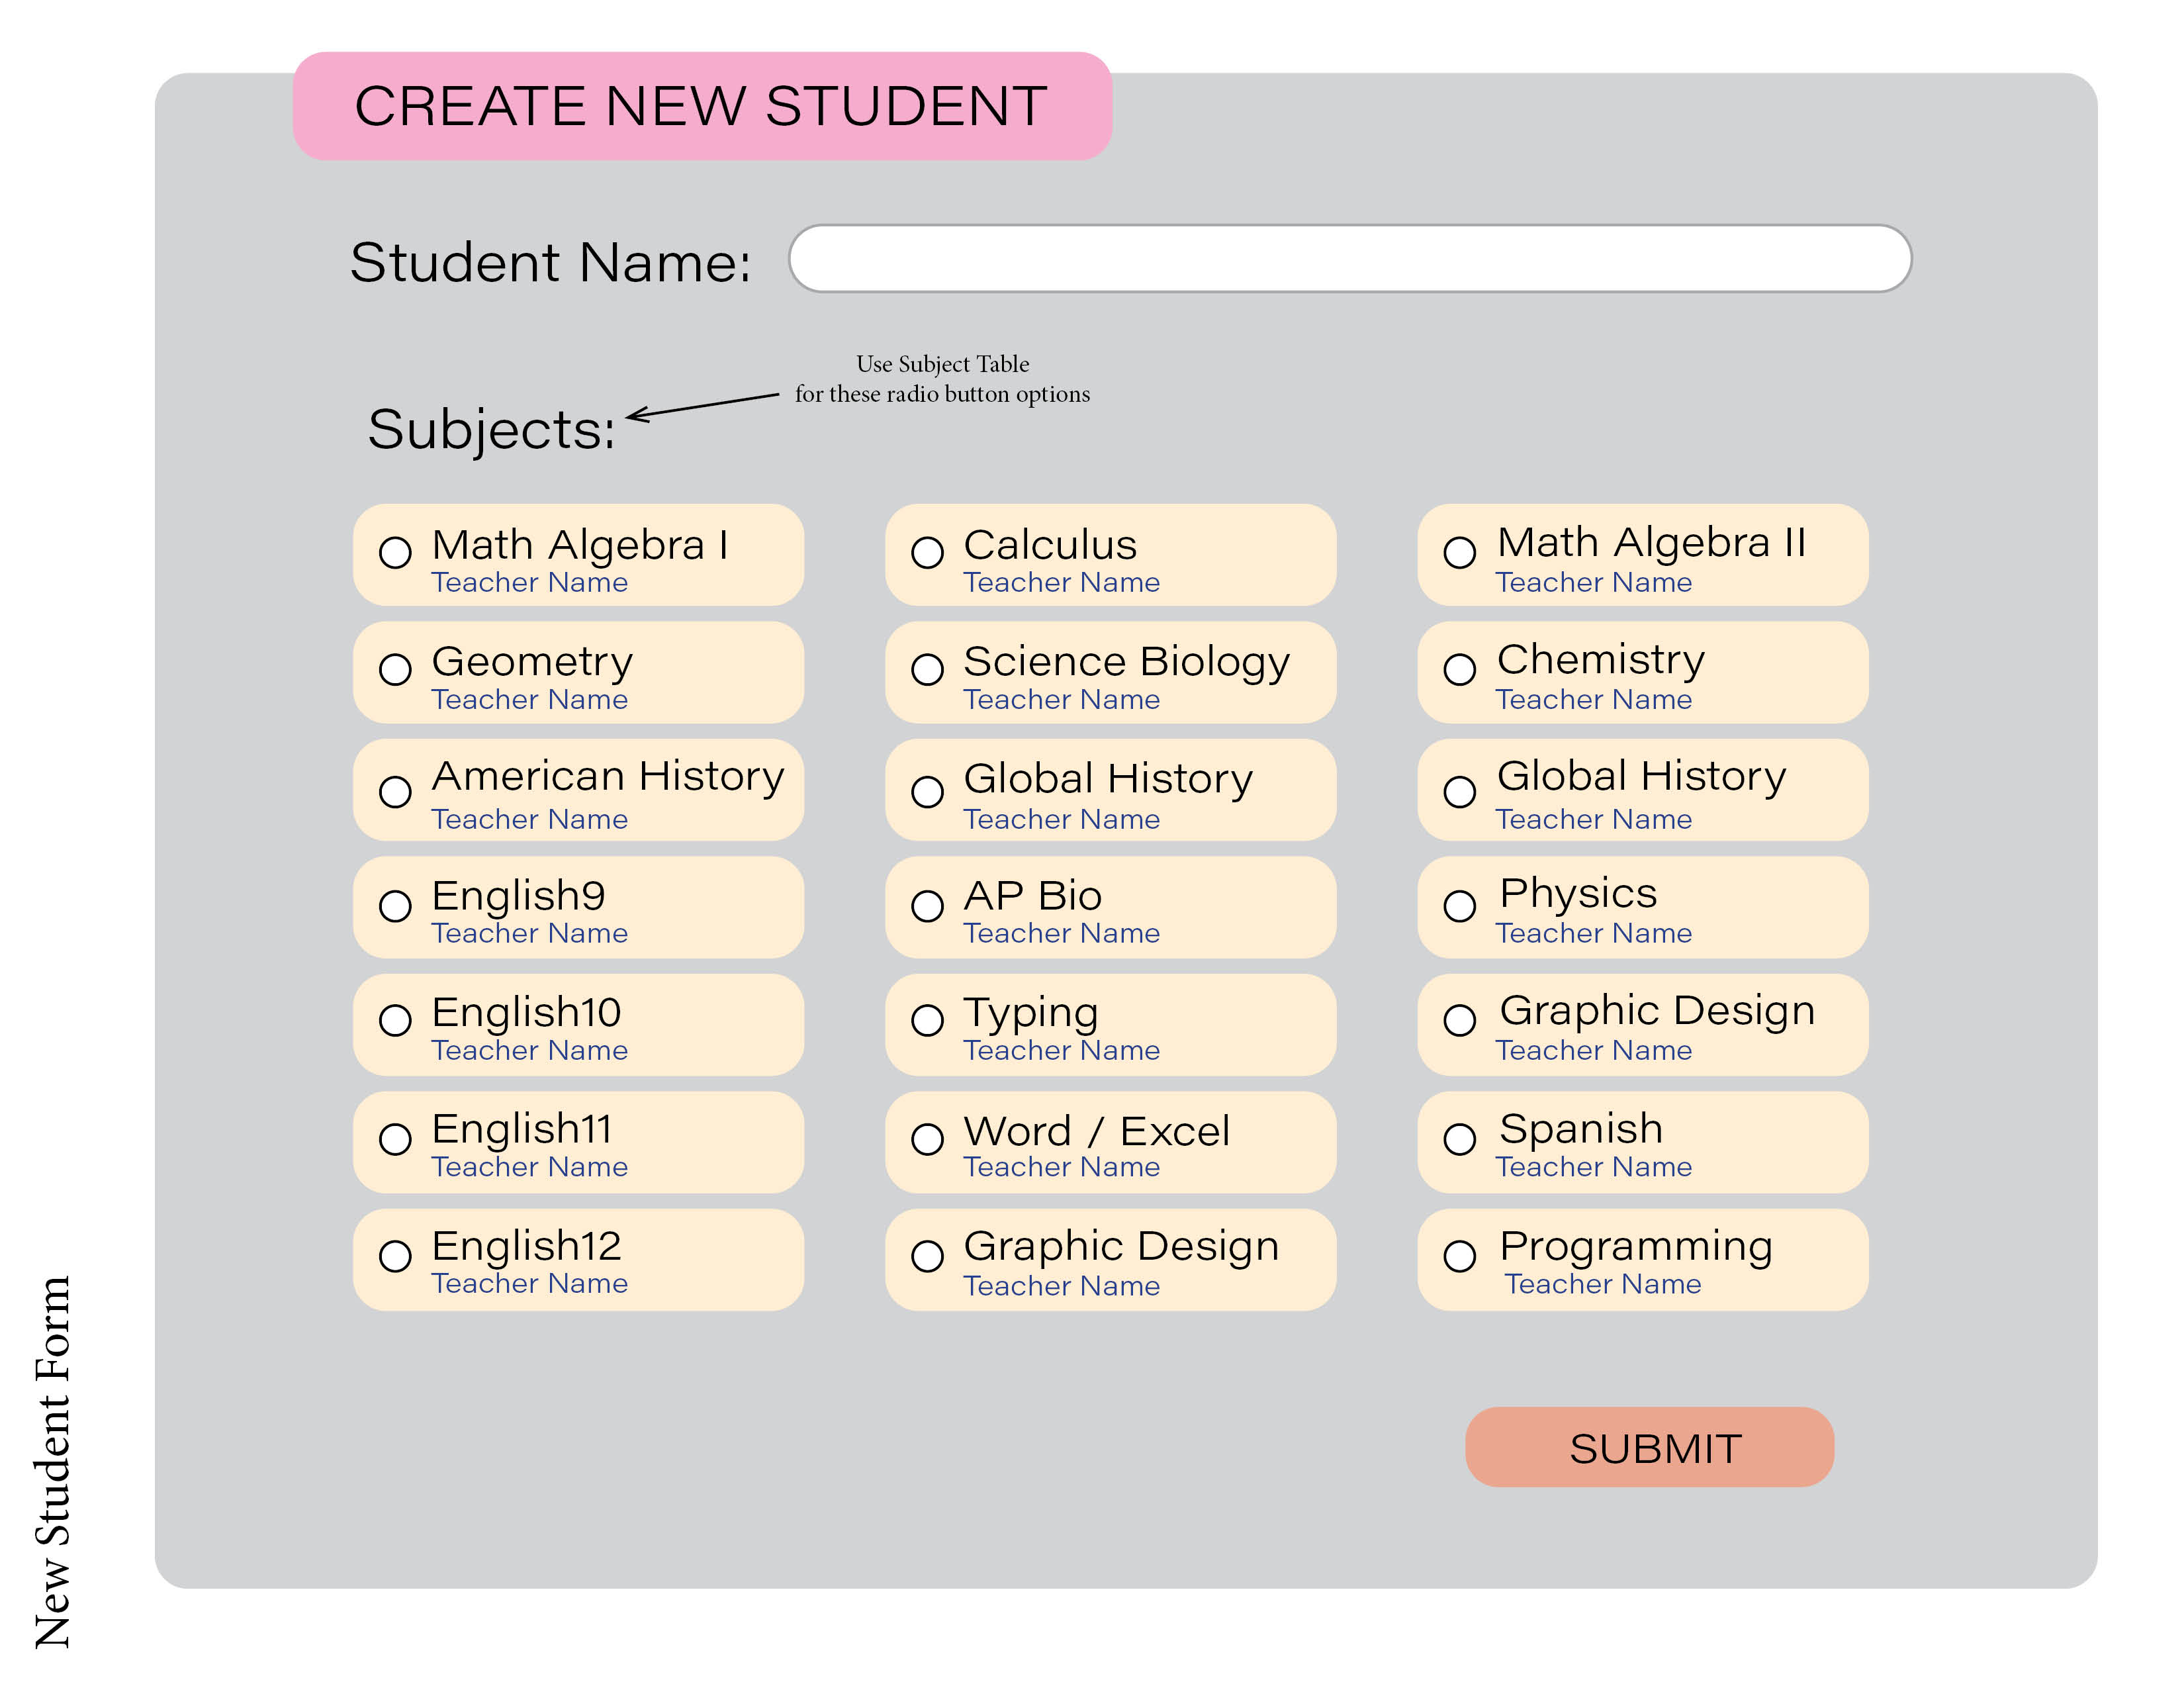

**? Class Enrollment:** NAVIGATION I think is CORRECT Navigate to Class Enrollment Form- it worked once when I tried and I could not replicate results – please verify that it navigates to Teacher/Subject form

**Add New Semester button:** NAVIGATION IS CORRECT seems to record new dates properly

WANT TO SEE: WHEN NEW SEMESTER BEGINS WE NEED TO START WITH FRESH DATA – THERE ARE NEW CLASSES AND SUBJECTS – (Old data should be available still when admin clicks to change semester on record log or student portal as indicated in mockup notes)

**MOST IMPORTANT as is clear in project notes!**

**I need to be able to create a subject/class that has a teacher and students, log in as the teacher, mark who is present or late, see the records show up on the RECORD LOG and in the STUDENT PORTAL, I need to see that if the admin changes the record it is updated in the student portal – as of now there are too many errors to see the intended function of this program**

**DAILY RECORD LOG** – needs to be interactive/live as was requested

1. Admin needs to be able to click into and change absent type tags
2. In the previous project account, we requested to add an absence type “UNIFORM”
3. Admin needs to be able to click in to notes and adjust or add or to add a new note
4. Admin needs to be able to click into Achrayus Grade and adjust manually
5. Admin needs to be able to click into date and navigate to previous records
6. We need to see a record of teacher name and subject with blank if all students are marked as present so that we know she marked her attendance, even if there are no absent students
7. There are formula triggered actions that should occur with each absence type tag – please refer to project pdf notes for this
8. Admin needs to be able to add a record – using the “ADD RECORD BUTTON” that is on the top of the page

There should appear a table with all the fields in the record log for her to add a record.

1. We did not include in the design mockup, but requested via freelancer message to please include in-line delete for records
2. When admin click on student name, it should navigate to STUDENT PORTAL with admin right to make adjustment, change tags, edit or add notes etc.

Student Portal: navigation is correct, need to see actual portal log in reality populated by teacher attendance data

Student log in to Student PORTAL

Should have view only access to that student personal record only which is determined by email

all pages in admin view can have a return to home button on bottom right of screen

here is the home button to return main home.



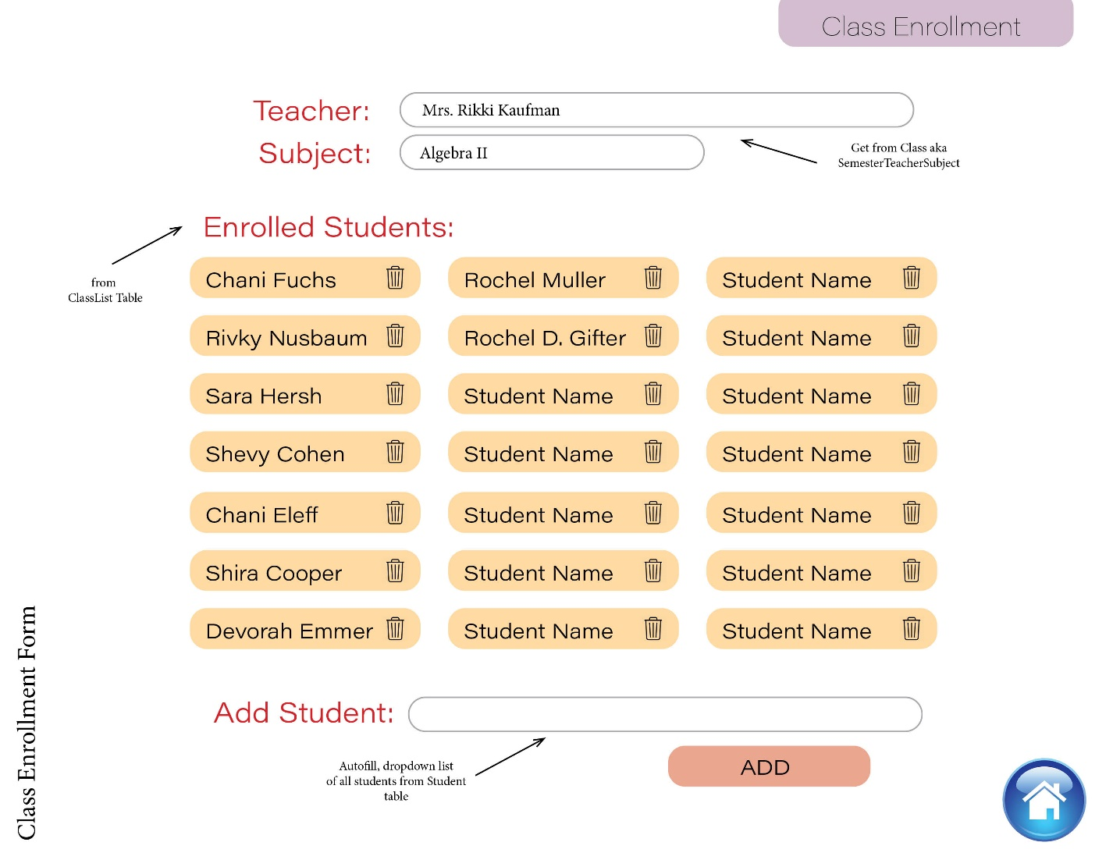

**ADDITION TO ERRORS**

I was just now able to log in as a teacher after adding multiple data and now I see it does not navigate correctly, teacher login should navigate to TAKE ATTENDANCE FORM - see attached, which should allow teacher to choose her subject roster which should then navigate to mark students present or absent –

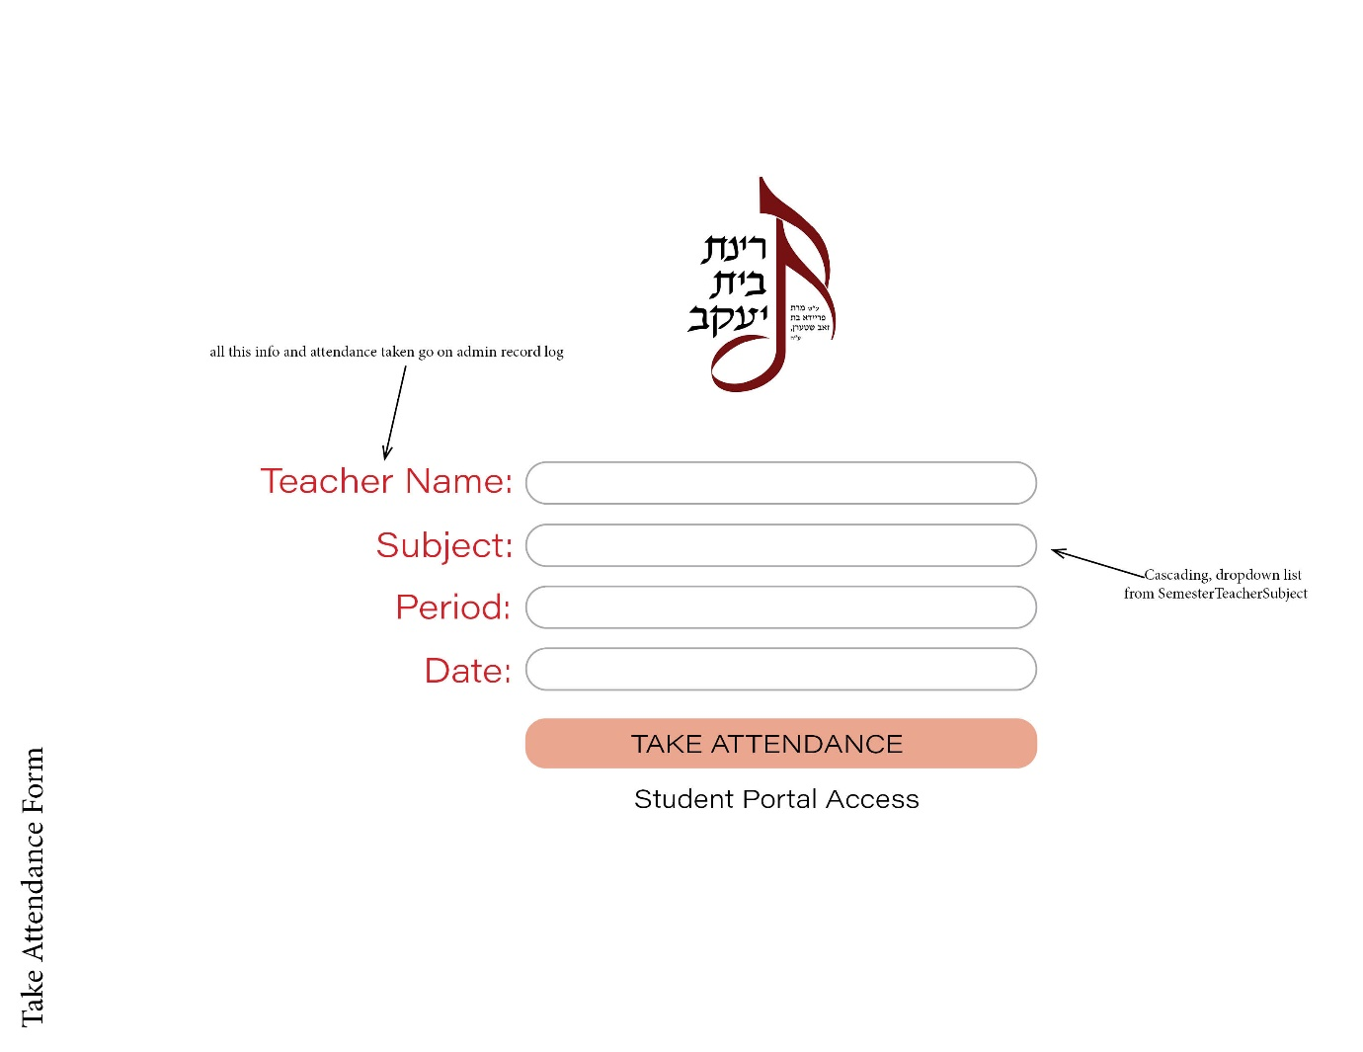as one teacher can teach multiple subjects